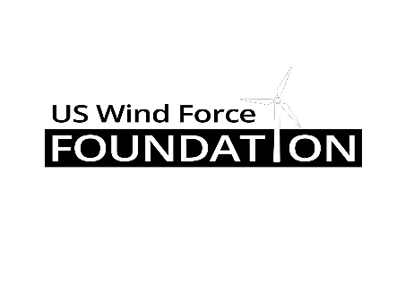

2022 GRANT APPLICATION
Instructions

This application is for use in applying for a grant from the US Wind Force Foundation. The information provided in this application will be used by the Foundation and its Allocation Committee to evaluate your organization’s grant request, so it is imperative that you submit detailed, accurate information.

Note: Incomplete applications will not be considered. Past recipients that have failed to provide follow-up reports, or otherwise failed to comply with the requirements in the funding letter, will not be considered for funding.

This year, the foundation is renewing its commitment to an emphasis on “bricks and mortar” projects. Simply put, this means enduring, physical, projects that will continue to provide community benefits for years to come. Applications that meet these criteria will be given priority.

Please return a completed Grant Application to be considered for a grant to be awarded this year. If a section or question is not applicable to your grant, please indicate so. In addition, feel free to add any supplemental information or materials that may be helpful to our understanding of your project/program. Applications must be emailed to foundation@uswff.org or postmarked to 159 Lakewood Road, Greensburg, PA 15601, no later than March 31, 2022 to be considered. We prefer that you send the application electronically, if possible, to save having to scan it for distribution to the allocation committee. However, we understand that not everyone has scanning capabilities and will accept hard copies, if necessary.

It is acceptable to retype this form on your own or to fill it out by hand; please use blue or black ink and write legibly.

REQUIRED DOCUMENTATION

  - Completed 2022 Grant Application

  - Project Budget

  - Financial Statements (Balance Sheet, Profit & Loss Statement)

  - Form 990

  - IRS Determination Letter

  - Current Board of Directors Roster

GENERAL INFORMATION REGARDING YOUR ORGANIZATION

- Organization’s Legal Name:

- Mailing Address: ________ _____

_____

- County: __________________________________________________________

- Contact, Title: _______

- Telephone Number: ___

- E-Mail Address: _____

- Grant Amount ($) Requested:

- Proposed Grant Use: _____

- Application Dated: ____

- Please provide us with a brief history of your organization. Be sure to include the date your organization was founded, as well as its experience and expertise in its given field, using specific examples whenever possible. Use additional pages, if necessary.

INFORMATION REGARDING YOUR GRANT REQUEST AND YOUR ORGANIZATION’S CHARITABLE PROJECTS AND PROGRAMS:

I. What is the amount of your grant request? $

II. What is the total budget for the project or program for which this request is made?

III. List other sources of funds for your organization’s project or program.

IV. Please describe how the organization proposes to utilize funds from the Foundation, if awarded. Include a description of how the award will be administered and by whom. Use additional pages, if necessary.

V. Describe (1) why your organization’s project or program is necessary; (2) who will be served by the project or program, and where; (3) how the project or program furthers the Foundation’s charitable purpose; and (4) how your organization will evaluate the success of its project or program. Use additional pages, if necessary.

FINANCIAL INFORMATION REGARDING YOUR ORGANIZATION

Please attach the following information:

- Budget and all sources of income for the proposed project.

- Most recent certified, audited financial statements, if available. If certified, audited financial statements are unavailable, please provide copies of your organization’s most recent financial statements as approved by your governing body.

- Most recent Form 990 or other federal tax return.

- Determination of Tax-Exempt Status Letter from the Internal Revenue Service.

- Board of Directors Roster.

APPLICANT’S ACKNOWLEDGMENTS

By submitting this application, your organization acknowledges and agrees that:

- Incomplete applications will not be considered.

- US Wind Force Foundation, Inc. is under absolutely no obligation to award a grant to your organization.

- If awarded a grant, your organization will use the funds only for the purpose(s) for which the grant is made.

- If awarded a grant in relation to a program or project lasting greater than ninety (90) days, your organization is required to submit periodic progress reports in a form promulgated by the Foundation, with the first such report being due not later than ninety (90) days after the date of your grant award letter, and your organization shall continue to make such reports each ninety (90) days thereafter until such organization’s project or program is completed.

- If awarded a grant, regardless of the duration of the program or project for which your organization may be awarded a grant, a final report in a form promulgated by the Foundation shall be due within ninety (90) days of the completion of your organization’s project or program.

- If it appears that grant funds are misused and/or diverted from their intended purpose, the Foundation reserves the right to withhold undistributed funds and/or recover such funds.

I CERTIFY, TO THE BEST OF MY KNOWLEDGE, THAT:

The tax-exempt status of this Organization is still in effect, this Organization does not support or engage in any terrorist activity, and if a grant is awarded to this Organization, the proceeds of that grant will not be distributed to or used to benefit any organization or individual supporting or engaged in terrorism, or used for any other unlawful purpose.

Signatures:

_____________________________________ _____________
President, Board of Directors Date

_____________________________________ _____________
Executive Director Date

